Architecture Design

## Swiggy Delivery Outlet data analysis

|  |  |
| --- | --- |
| **Written By** | Sarvesh S |
| **Document Version** | 0.1 |
| **Last Revised Date** |  |

DOCUMENT CONTROL

# Change Record:

|  |  |  |  |
| --- | --- | --- | --- |
| **VERSION** | **DATE** | **AUTHOR** | **COMMENTS** |
| 0.1 | 05/01/2022 | Sarvesh S | Introduction, architecture and deployment defined |
|  |  |  |  |
|  |  |  |  |
|  |  |  |  |

**Reviews:**

|  |  |  |  |
| --- | --- | --- | --- |
| **VERSION** | **DATE** | **REVIEWER** | **COMMENTS** |
|  |  |  |  |

# Approval Status:

|  |  |  |  |  |  |
| --- | --- | --- | --- | --- | --- |
| **VERSION** | **REVIEW DATE** | **REVIEWED BY** |  | **APPROVED BY** | **COMMENTS** |
|  |  |  |  |  |  |

## Contents

1. Introduction… 04
   1. What is Architecture Design Document? 04
   2. Scope 04
2. Architecture 05
   1. Power Bi Server Architecture 05
   2. Data Source 06
   3. Power Bi Desktop 07
   4. Power Bi Service 07
   5. Power Bi Report Server 07
   6. Power Bi Gateway 08
   7. Power Bi Mobile 08
   8. Power Bi Embedded 08
3. Deployment 08
   1. Deployment Options in Tableau 08
   2. Publishing of Data sets and Reports from Power Bi desktop 09

## What is Architecture design document?

Any software needs the architectural design to represents the design of software. IEEE defines architectural design as “the process of defining a collection of hardware and software components and their interfaces to establish the framework for the development of a computer system.” The software that is built for computer-based systems can exhibit one of these many architectures.

Each style will describe a system category that consists of :

* A set of components (eg: a database, computational modules) that will perform a function required by the system.
* The set of connectors will help in coordination, communication, and cooperation between the components.
* Conditions that how components can be integrated to form the system.
* Semantic models that help the designer to understand the overall properties of the system.

### Scope

Architecture Design Document (ADD) is an architecture design process that follows a step-by- step refinement process. The process can be used for designing data structures, required software architecture, source code and ultimately, performance algorithms. Overall, the design principles may be defined during requirement analysis and then refined during architectural design work.

## Architecture

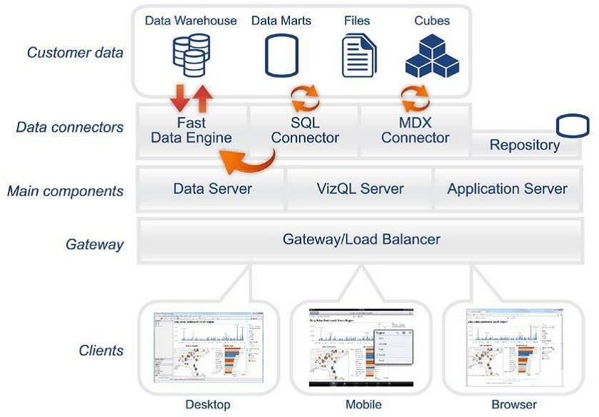

Power Bi Server Architecture *Power BI is a business suite that includes several technologies that work together.* To deliver outstanding business intelligence solutions, Microsoft Power BI technology consists of a group of components such as:

* + Power Query (for data mash-up and transformation)
  + Power BI Desktop (a companion development tool)
  + Power BI Mobile (for Android, iOS, Windows phones)
  + Power Pivot (for in-memory tabular data modeling)
  + Power View (for viewing data visualizations)
  + Power Map (for visualizing 3D geo-spatial data)
  + Power Q&A (for natural language Q&A)

In simple terms, a Power BI user takes data from various data sources such as **files, Azure source, online services, Direct Query or gateway sources.**

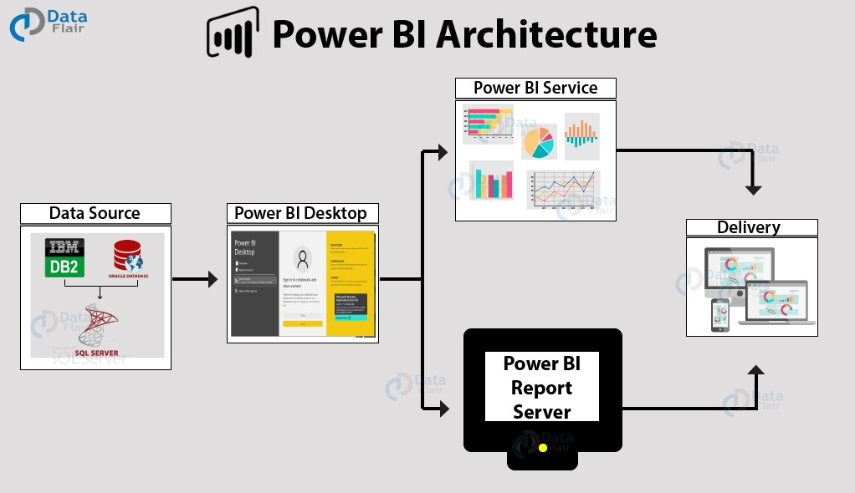

### Data Sources

An important component of Power BI is its vast range of data sources. You can import data from files in your system, cloud-based online data sources or connect directly to live connections. If you import from data on-premise or online services there is a limit of 1 GB. Some commonly used data sources in Power BI are:

* + Excel
  + Text/CSV
  + XML
  + JSON
  + Oracle Database
  + IBM DB2 Database
  + MySQL Database
  + PostgreSQL Database
  + Sybase Database
  + Teradata Database
  + SAP HANA Database
  + SAP Business Warehouse server
  + Amazon Redshift
  + Impala
  + Google Big Query (Beta)
  + Azure SQL Database
  + Salesforce Reports
  + Google Analytics
  + Facebook
  + GitHub

### Power BI Desktop

Power BI Desktop is a client-side tool known as a companion development and authoring tool.

This desktop-based software is loaded with tools and functionalities to *connect to data sources, transform data, data modeling and creating reports.*

You can download and install Power BI Desktop in your system for free. Using Power BI Desktop features, one can do *data cleansing, create business metrics and data models, define the relationship between data, define hierarchies, create visuals and publish reports.*

### Power BI Service

Power BI Service is a web-based platform from where you can *share reports made on Power BI Desktop, collaborate with other users, and create dashboards.*

It is available in three versions:

* + Free version
  + Pro version
  + Premium version

Power BI Service is also known as, **“Power BI.com”**, **“Power BI Workspace”, “Power BI**

**Site”** and **“Power BI Web Portal”**. This component also offers advanced features like *natural language Q&A* and *alerts*.

### Power BI Report Server

The Power BI Report Server is similar to the Power BI Service. The only difference between these two is that Power BI Report Server is an on-premise platform. It is used by organizations who do not want to publish their reports on the cloud and are concerned about the security of their data.

Power BI Report Server enables you to create dashboards and share your reports with other users following proper security protocols. To use this service, you need to have a Power BI Premium license.

### Power BI Gateway

This component is used to connect and access on-premise data in secured networks. Power BI Gateways are generally used in organizations where data is kept in security and watch. Gateways help to extract out such data through secure channels to Power BI platforms for analysis and reporting.

### Power BI Mobile

Power BI Mobile is a native Power BI application that runs on iOS, Android, and Windows mobile devices. For viewing reports and dashboards, these applications are used.

### Power BI Embedded

Power BI Embedded offers APIs which are used to embed visuals into custom applications.

## Deployment Description

### Deployment in Power Bi

The deployment process lets you clone content from one stage in the pipeline to another, typically from development to test, and from test to production.

During deployment, Power BI copies the content from the current stage, into the target one. The connections between the copied items are kept during the copy process. Power BI also applies the configured deployment rules to the updated content in the target stage. Deploying content may take a while, depending on the number of items being deployed. During this time, you can navigate to other pages in the Power BI portal, but you cannot use the content in the target stage.

### Publishing of Data sets and Reports from Power Bi Desktop

When you publish a Power BI Desktop file to the Power BI service, you publish the data in the model to your Power BI workspace. The same is true for any reports you created in Report view. You’ll see a new dataset with the same name, and any reports in your Workspace navigator.

Publishing from Power BI Desktop has the same effect as using Get Data in Power BI to connect to and upload a Power BI Desktop file.

